Big Kush Guys | Sample: 957  Sample Received:60824
CoolKush  Flower | Total Terpene: 2.06%  Total Cannabinoids: 12.67%

Terpenes
(Testing Method: GC)
Date Tested: 062925
Analyte Mass Mass  % mg/g  Camphene 0.011 0.11  Alpha-Pinene 0.107 1.07  beta-Pinene 0.077 0.77  beta-Myrcene 0.089 0.89  delta-3-Carene ND ND  alpha-Terpinene ND ND  p-Isopropyltoluene (p-Cymene) ND ND  d-Limonene 0.278 2.78  Ocimene 0.041 0.41  gamma-Terpinene ND ND  Terpinolene 0.005 0.05  Linalool 0.029 0.29  (-)-Isopulegol 0.016 0.16  Geraniol 0.015 0.15  beta-Caryophyllene 0.715 7.15  alpha-Humulene 0.304 3.04  Nerolidol 0.054 0.54  (-)-Guaiol 0.143 1.43  (0)-alphabisbolol 0.124 1.24  8-Cineole (Eucalyptol) 0.009 0.09  Caryophyllene Oxide 0.044 0.44  Total 2.061 20.61 | Primary Aromas  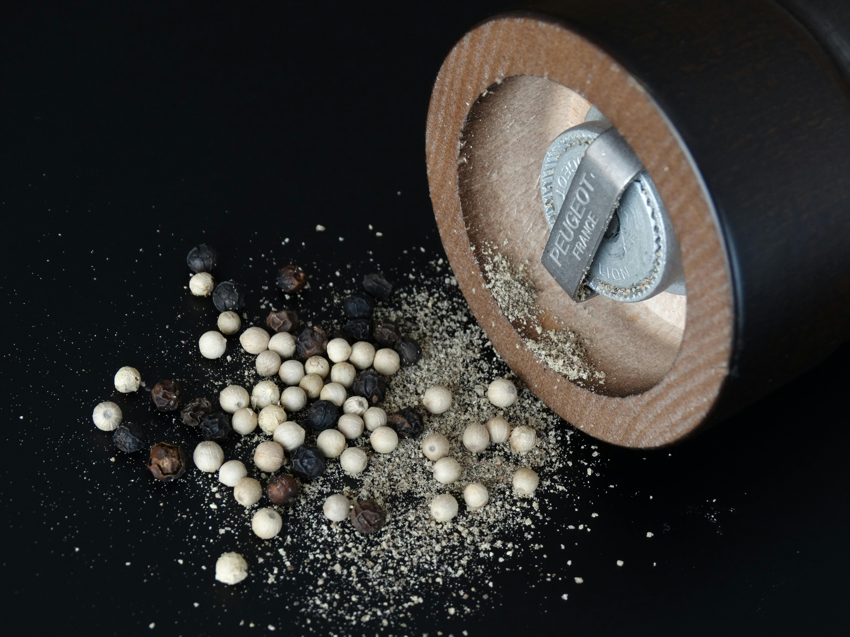  Peppery  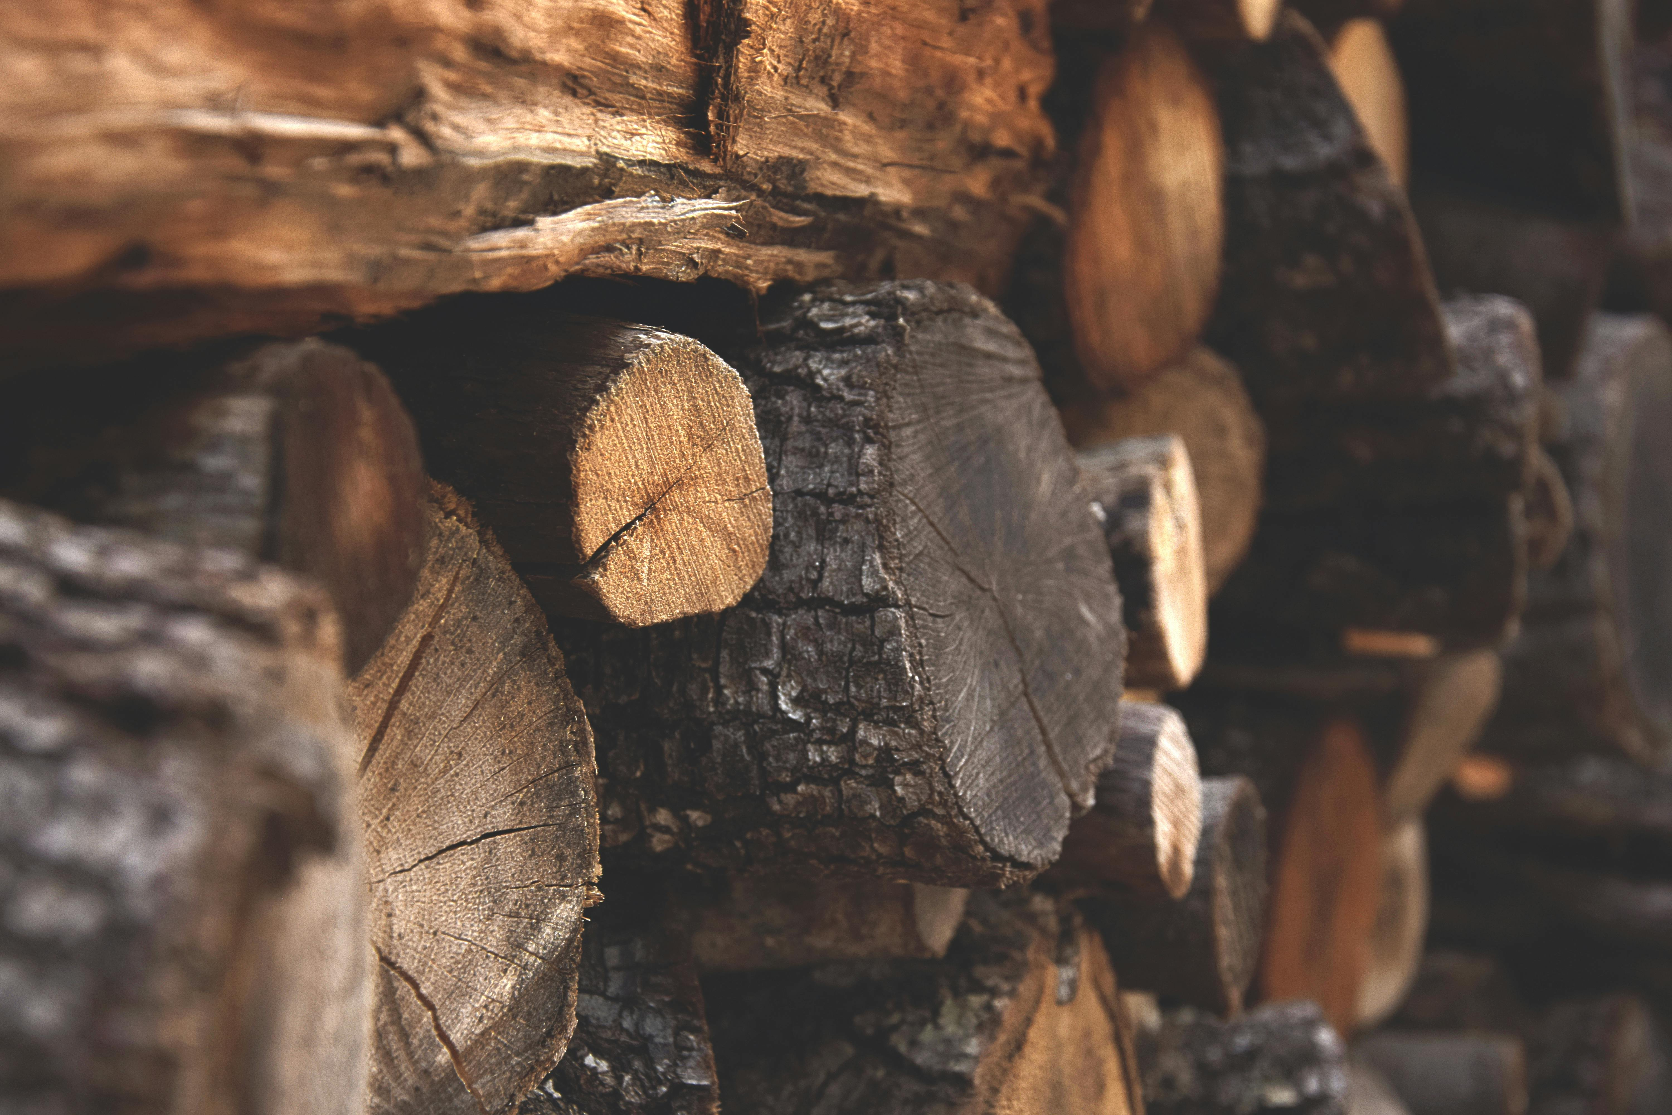  Woody  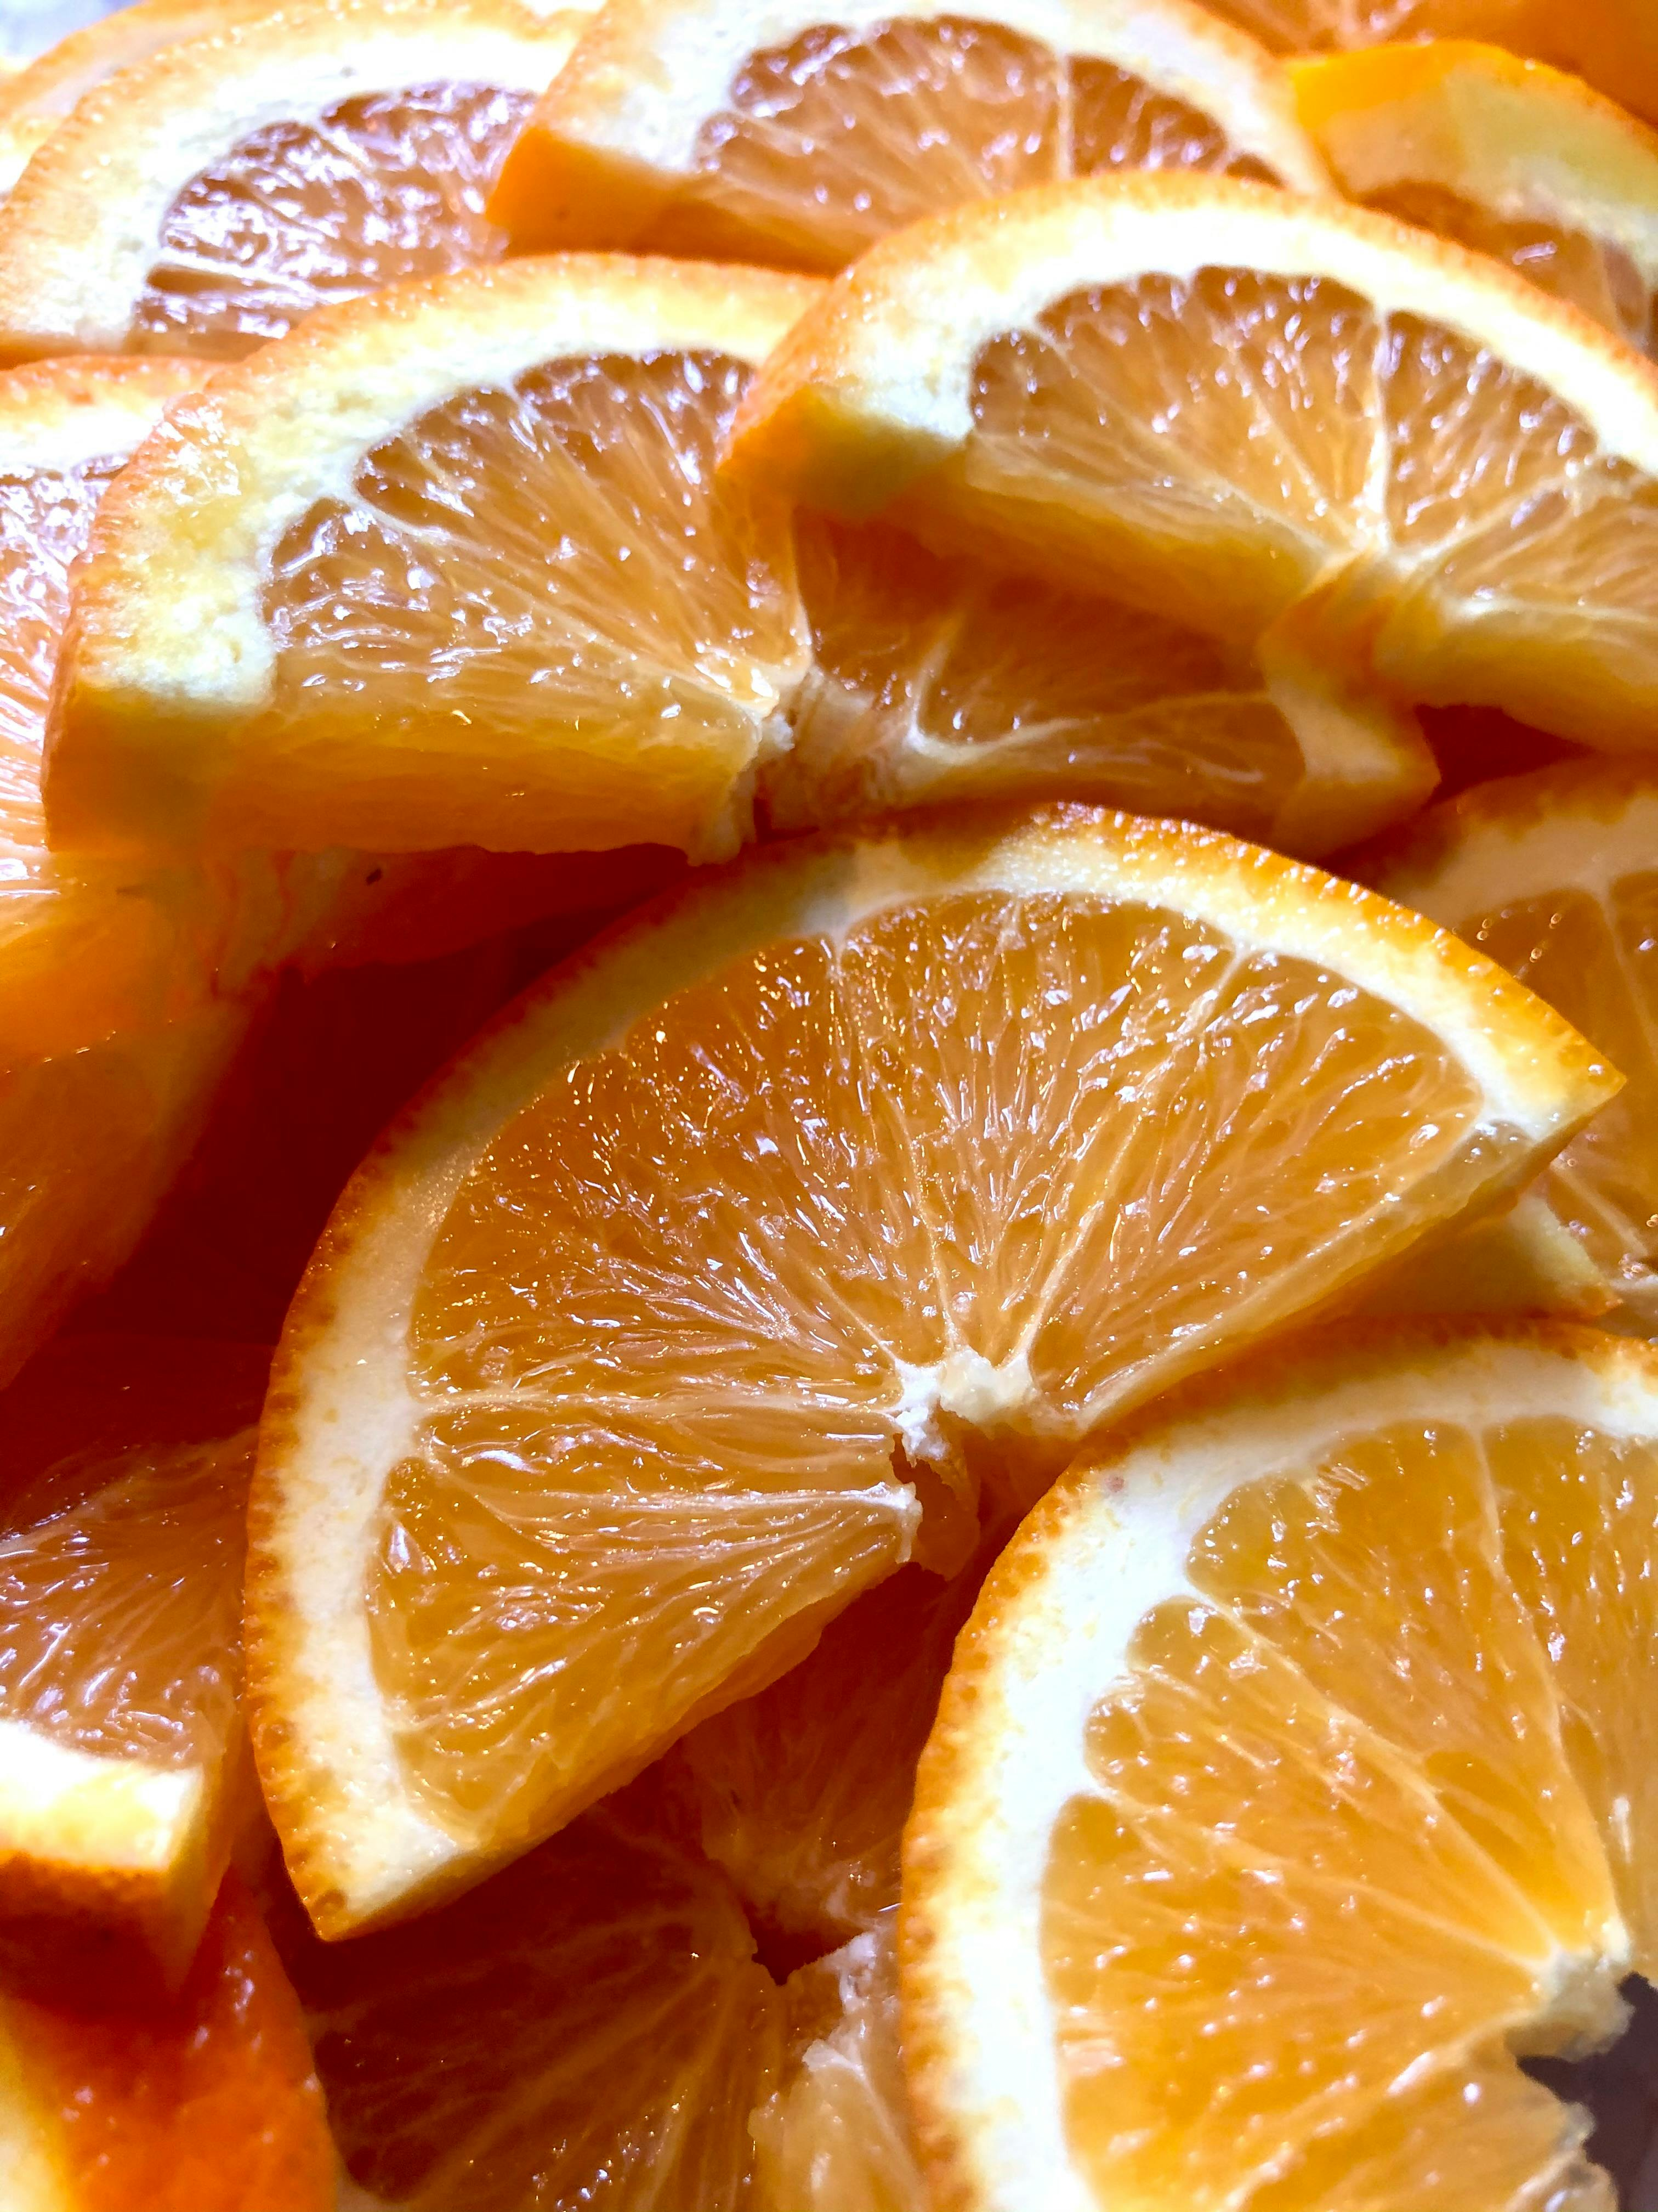  Citrus

Cannabinoids
(Testing Method: HPLC)
Date Tested: 06272025

Analyte | Mass | Mass
 | % | mg/g
Cannabidivarin (CBDV)total | ND | ND
Cannabinol (CBN)total | NT | NT
Cannabidiolic Acid (CBDA)total | 0.102 | 1.02
Cannabigerolic Acid (CBGA)total | 0.254 | 2.54
Cannabigerol (CBG)total | 0.075 | 0.75
Cannabidiol (CBD)total | ND | ND
Tetrahydrocannabivarin (THCV)total | 0.094 | 0.94
delta-9-Tetrahydrocannabinol (delta-9 THC)total | 0.426 | 4.26
delta-8-Tetrahydrocannabinol (delta-8 THC) total | ND | ND
Cannabichromene (CBC)total | ND | ND
delta-9-Tetrahydrocannabinolic acid (THCA)total | 11.722 | 117.22
Total | 12.673 | 126.73
ND = Not Detected.; NT = Not Tested

{{sampleImage}} | 11.72 THCA 0.43 Delta-9 THC  12.67 Total Cannabinoids ND Total CBD

